1. **INTRODUCTION**

Medication is simply a method to treat or prevent disease using drugs or other form of medicine. Analogously, Pharmacy is generally the science or practice of the preparation and dispensing of such medicinal or pharmaceutical drugs used for treatment.   
Pharmacy is also synonymous as a point of sales where the medicines are dispensed.  
  
Online Medication System, in concise definition, is a concept to combine pharmaceutical e-commerce site and a bioinformatic medication and health record reference that helps deal with purchase and delivery of the necessary medication (telemedicine) while serving as a portal to a reference for the prescribed medication itself along with information about various different medical conditions in the past.

In this project about an Online Medication System, it is tried to encompass the current prevailing problem in the society about medication for most of the age groups above their 40s to get informed about various parameters related to their medical condition that should be an essential part to put the consumer on state of self-awareness and dispense any medicine with convenience to the ambience of the customer themselves. Hence, we have listed out following features to be listed for development of out system:

* **Target Products:** The major items on list we have for display are the pharmaceutical and herbal, medicine and cosmetics. Pharmaceutical products need to be classified and ordered according to their sensitivity of being mishandled, so a prescription n for products as Antibiotics or Narcotics should be compulsion, while the herbal and cosmetics can be purchased without hassle.
* **Prescription Upload:** The user can have their prescription from a certified health professional, scanned or photographed and then upload it to the system where an administrator (with certified pharmaceutical experience) shall manually process forward and handle the request of medication purchase.
* **Medicine Dispense | Return:** The users who have their products purchased from the system can have their orders dispensed and delivered with the sales invoice. So, incase if the product is unwanted, unused and intact can be returned for a cash back with the sales invoice as an evidence of purchase from system.
* **EHR:** Electronic Health Record is a similar concept of an e Clinical Record where the user can upload their current level of their tested parameters from the laboratory reports on the system to keep track and evaluate with their past levels to surmise and be self-aware and conscious about the improvements.
* **Symptoms Diagnosis | Prognosis:** Based on a user-friendly interface, it is intended to take a brief questionnaire of medical symptoms and gather their response and according to the backdrop of the system programmed can be used to speculate the possible diagnosis of a certain disease or the prognosis.
* **Medication | Medical Conditions Reference:** It is intended to keep all the necessary information compiled together about various forms and class of pharmaceutical drugs and diseases in concise and intricate manner as per user’s choice. This feature can have a huge impact in the rural health. As health assistant deployed to such sites can have offline access and searching capability to complicated conditions and find the solutions while being updated about different medication next time the system is synchronized using internet.

Telemedicine is one of the progressive technology models, which has evolved in the last few years and has enabled accessibility to the medication required and easily on tap of a button. Another synonyms innovation to it, that has positioned itself as an attractive model in the healthcare space is ePharmacy, which direct and browse extensive online catalogue of health products and medicines and have it delivered directly to customer.  
Many health-related processes stand to be reshaped by the Internet. In clinical settings, the Internet enables care providers to gain rapid access to information that can aid in the diagnosis of health conditions or the development of suitable treatment plans.

It can make patient records, test results, and practice guidelines accessible from the examination room. It can also allow care providers to consult with each other electronically to discuss treatment plans or operative procedures. At the same time, Internet supports a shift toward more patient-centered care, enabling consumers to gather health-related information themselves; to communicate with care providers electronically; and to receive care in the home. Internet can reduce administrative overhead associated with health of the nation's population, train health care providers, and lead to new insights into nature of disease.

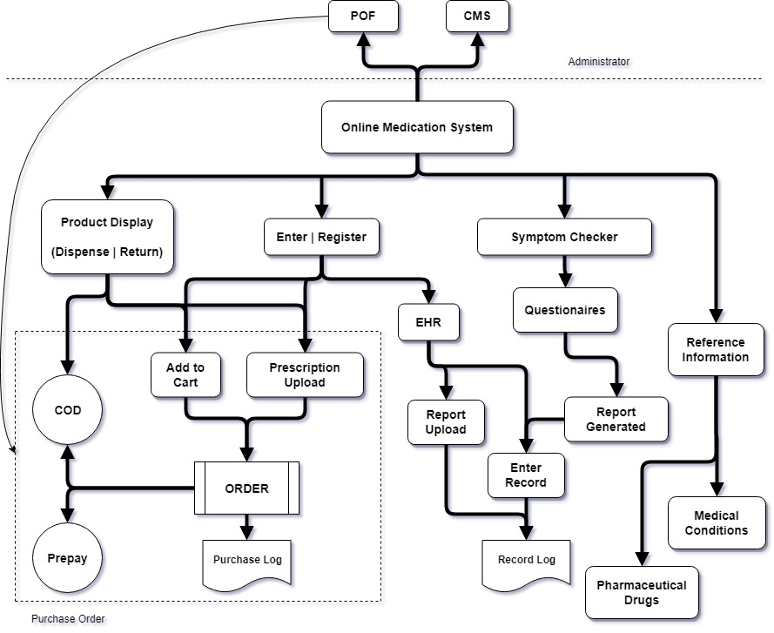

**Fig. 1.1:** Online Medication System – System Process Layout

The System is divided upon two sections over which a line that separates the level of authority to access information and change controls are maintained of the system itself. The Administrator has full right to access information layout of the system while the User can only access the functions that lie below the lines separating level of authority.

The prices may vary according to the region stayed but the deviation would be under constrained standards, such as delivery distance or added sales values, inflation and tax.

Sales of medication or running a pharmacy requires a certain licensing from Nepal Pharmacy Council (NPC). The license can be rented paying against an annual charge. But for the initial trial purpose, the service shall remain dormant and shall only be deployed after the proper license and legal process to register the organization is accomplished. The pharmaceutical drugs can be classified in various ways and it is intended to categorize them ‘Therapeutically’, i.e. by the condition or cases being used, and according to ‘Drug Schedule’, i.e. by the level of restriction applied against the substance abuse by the federal law or the central government for pharmaceutical sales.

In Product Display, the items, especially the ones that can be allowed for purchase without prescription, are kept in a linear, minimalistic fashion to be easily viewed by the customers for extensive selection before processing for purchase. Purchase can be done in two ways:

1. Adding desired product to the Cart and process for order with requirement of log in with consumer details provided clearly if ordered Restricted Class.
2. Uploading the Prescription and process for order again with requirement of log in with consumer details if prescribed medication is of Restricted Class.
3. Calling the operators under administrative panel and order viewed products under general sales only. Other pharmaceutical drugs under Class of Prescription and Restricted can only be ordered with recommendation of professional physician or doctor with clearly specified reasoning.

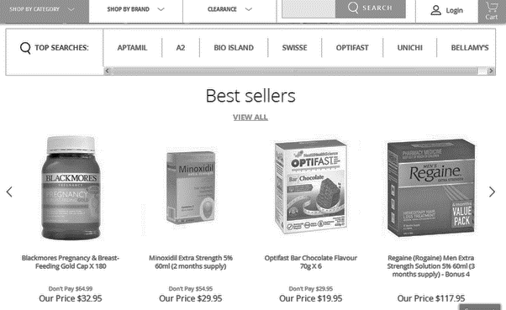

**Fig 1.2:** Online Medication System – Product Display

The Purchased ordered shall then be processed after the payment is accomplished or either user can opt for Cash on Delivery as well. Then some authorized personnel as administrator would perform Purchase Order Forwarding then validating and verifying the user and the medication being issued and shall be registered under Purchase Log.

As we want to keep a minimalistic view, in the section of Sign in and Sign up, it is only intended to ask basic information and verify either with user’s E-mail or Cell Number. Once the user has been verified and logged in, now they can be allowed with the facility to retain their health report status on to the system via. direct scan and upload or manual enter their vitals information to the system. The entered data is then also logged in the system as an Electronic Clinical Record Log under the user’s personal account.

As an analogy of Expert System, the user can walk through the symptom checker section where, they can check for a possible diagnosis for a disease or prognosis of a disease by answering a list of questionnaires that would be put forth by the system. It is intended to make the interaction between the user and the system more user-friendly and in way user would feel comfortable to express and extricate complication for a better and accurate diagnosis. The questionnaires will be kept consulting with a medical health expert, physician or medical professional as doctors and public health assistants.

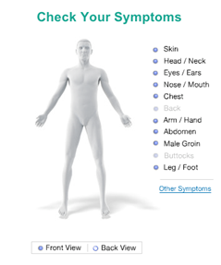  
 **Fig 1.3:** Online Medication System – Symptom Checker

The Reference Information section shall consist of utmost possible list and collection of information on various Medical Conditions (diseases), its cause, symptoms, mitigation measures, and treatments with the means of Medication (pharmaceutical drugs or herbal remedies), then again consisting information about drug composition, classification, and type on basis of wide use and high market evaluability in the market.  
Administration section consists of Purchase Order Forwarding as mentioned earlier and Content Management System, custom built to enter the information into the system. The data as new medical drugs entry and disease shall be logged in the system with the proper citation and reference to the source of where the data was originally fetched.

Such information does not only help individual to be self-aware but also informed about the medication they are taking, the dosage and helps to mitigate major issues amplified by blunders, or carelessness or medics or patients themselves. Another such use of information can be in research and education. Scholars studying in specified field can help benefit by taking authentic information on such topics to be self-notified and perform experiments and extensive research for development or discovery in this field.

1. **OBJECTIVE**

Incisively, the intended goal of Online Medication System is to generally combine and tweak the concept of Telemedicine with ePharmacy along EHR and general medication reference. Some keynotes are as briefly mentioned here:

1. **Consumer convenience of access:**

The consumers would be able to order medicines in a convenient manner, from their mobile or computer. It can significantly help patients who are sick and not in a condition to go out to find a pharmacy or aggregate supplies of making otherwise hard to find medicines across the country easy for the consumer reach

1. **Consumer education:**

Online pharmacies and medication database have the technology infrastructure to provide information to consumers, such as drug interactions, medicine reminders and information on cheaper substitutes. An aware consumer can benefit from the knowledge, which is distributed through an electronic medium.

1. **Data records:**

All medicine purchased can be tracked effectively reducing the problem of misreckoning past medication information and dosage and avoid drug abuse.

1. **Easy return policy with money back guarantee:**

Medicines purchased by end consumer can be returned hassle-free with given rate of depreciation on cash back only with sales bill as evident of purchase.

1. **Safe delivery of medicines by validating the prescriptions:**Medicines can be delivered safely without hassle by validating the prescription provided by a health care professional that can be uploaded to the system.
2. **PROBLEM STATEMENT**

* **Conventional Pharmacies:** Traditional pharmacies usually have controlled drug distribution systems from the manufacturer. Validation and good distribution practices are followed. Home delivery of pharmaceuticals can be a desirable convenience but may not be available in most cases. Sometimes there can be lack of information or confusion on dosage of medication to be taken, hence we need a reference for it.
* **Uncontrolled Shipping** **and Distribution:** The shipment of drugs through the mail and parcel post is sometimes a concern for temperature-sensitive pharmaceuticals.  
  Uncontrolled conditions can include high and low temperatures outside of the listed storage conditions for a drug. For example, the US FDA found the temperature in the ambient air temperature was 38°C while a mail box in the sun could reach 58°C, and while medicine dispensed in a mail box while the receiver may not be informed about delivery would not considered a recklessness of courier as they may not or don’t have idea of proper treatment of dispensed medication as they treat all their parcel as same.
* **Past Clinical Report:** Past health reports have higher risk in physical existence as they have tendency to be tampered and lost easily. Online server can store such data and analyze it accordingly to the need. Symptoms can be fed through brief or extensive questionnaire and possible diagnosis of disease can be listed with possible medication.
* **Rural Health:** Rural areas are a prone region for most of commonly deadly disease’s outbreak. Health posts in such regions are uncertain to remain available and even those existing, lack certain updates and information. Such problems could be mitigated by use of internet, for ease in information access, alongside with a system fathomed easily.

1. **SCOPE**

The online medication concept has been used largely in developed countries. With right and timely information, it is possible to reap the rewards of technology in different fields by effectively developing and addressing multiple issues in sectors such as:

1. **Digital Marketing:** In a similar trend that E-commerce has revolutionized the way in which consumers are able to purchase on a click of a button, it is also possible to exhibit the products and order medicine in a convenient manner, from their mobile or computer. This will significantly help patients who are not in a condition or having difficulty to reach for their medications.
2. **Tele-Medicine:** Information is what has made possible for a change in idea and technology can have a huge implication in rural development by ease of conveyance of information. As to the growing pace in technology and revolution in information access, it could be likewise easy to make a system interpreted in the way how people from such regions could fathom and be informed and aware of modern medication and various medical conditions.
3. **Medical Records and Informatics:** List of medical record of prescription of a patient can be stored, analyzed and monitored to give heads up of previous and current status of tested parameters in health check up with the used medication.
4. **Expert System:** Expert System is a piece of software which uses databases of expert knowledge to offer advice or make decisions in such areas as medical diagnosis. AI implemented system can help for better prognosis using EHR.
5. **Medical Institute and Practitioner:** The information provided on various pharmaceutical drugs and existing medical condition and services to deliver prescribed medication provided by this system could help benefit for the medical institutes and practitioners for their education and research purposes.
6. **LITERATURE REVIEW**
7. **Etymology and Background**

The word “Drugs” is an evolved term from Old French *drogue*, possibly from Middle Dutch *droge vate*, literally meaning ‘dry vats’, referring to the contents (i.e. dry goods). The herbs that were used to make medicine were in fact dried and then crushed and applied through different means, which was how the word was introduced in the current medical field. The word pharmacy is derived from Old French *farmacie*, via medieval Latin from Greek *pharmakeia* ‘practice of the druggist’, based on *pharmakon* ‘drug’.

In Baghdad the first pharmacies, or drug stores, were established in 754, under the Abbasid Caliphate during Islamic Golden Age. By 9th century, these pharmacies were state-regulated. In 1240 emperor Frederic II issued a decree by which the physician's and the apothecary's professions were separated. The first pharmacy-like shop in the human history was opened in Europe, that is dated back to 1241 in Trier, Germany.

There are old pharmacies still operating in Dubrovnik, Croatia, located inside the Franciscan monastery, opened in 1317; and in the Town Hall Square of Tallinn, Estonia, dating from at least 1422. The oldest is claimed to have been set up in 1221 in the Church of Santa Maria Novella in Florence, Italy, which now houses a perfume museum. The medieval Esteve Pharmacy, located in Llívia, a Catalan enclave close to Puigcerdà, also now a museum, dates back to the 15th century, keeping albarellos from the 16th and 17th centuries, old prescription books and antique drugs.

1. **Current Trend and Influence:**

A local analogy of a running organization in internet similar to the current project’s interest is the “Onlineausadhi.com”, an independent and licensed online pharmacy with free delivery system within the ring road axis of Kathmandu. They provide safe prescription drugs at a considerable price with quick and proper customer service alike any other retail pharmacy, they dispense required medications at the doorstep.

1. **Online Pharmacy**

Pharmacy is a shop that provides prescription drugs, where an experienced and – or certified pharmacist fulfils the request of the customer. The online pharmacy (or also synonymous with ePharmacy) is simple a pharmacy run on the internet whereas mentioned earlier, the prescription can be uploaded to the system by the user and the medication prescribed is delivered. Countries such as United States of America, Germany, United Kingdom and India have already mobilized this particular system. One earliest example of it is ‘Pharmacy2U’ founded by pharmacist Daniel Lee in 1999. Pharmacy2U is an online mail-order pharmacy located in the UK and has been involved in piloting the electronic transfer of prescriptions of medication in the UK.  
  
Pharmacy2U although became the UK's first online pharmacy. While, the British Medical Association expressed concern over the innovation, and the National Pharmaceutical Association resisted the move towards filling prescriptions online in 1999. UK health organizations persistently pushed back against online ordering in 1999 due to concerns over change in medical industry's infrastructure. Few days after they first opened, an inspection team arrived in order to scrutinize their business practices and structure but the result deemed positive and to stay open, leading to an amendment of the 1968 Medicines Act as well as the codes of ethics of the Royal Pharmaceutical Society in order to allow for establishment of Internet-based pharmacies.

1. **Electronic Health Record (EHR)**

EHR or Electronic Health Record is electronic patient records with electronic dispensing including decision support in handling alerts Electronic communication with HCPs and patients. It is moreover analogous with e-Clinical Record which keeps track of patient’s clinical record and reports the status. Electronic medical records (EMR) and Electronic health records (EHR) combining is kept in an archived form that includes important aspects for pathology practice and participation in use and structure.

There is an important distinction between EMR’s and EHR’s although these terms are sometimes used interchangeably. In addition to providing reference materials that define the difference as well as discuss connectivity between systems, other subjects to understand include the role of these electronic records for meaningful use, government regulations and incentives for their use, vendors, capabilities and the use of patient portals. EMR and EHR systems are generally purported to improve patient care, patient safety and public health and pathology informatics will be central in supporting these systems. Electronic medical and health records may also be an important vehicle to reduce cost by improving accuracy and reducing overutilization. The effective transmission of data across systems to produce meaningful health records requires standardization of data. It will be possible to provide electronic links for pathologists to better understand the condition and help them assume the role as leaders in providing electronic access and proper use of this health information for a better diagnosis.

1. **Medical Information Reference (MIR)**

‘Xenopharmacist.com.np’, now a dysfunctional site, is an example of an organization working as a combination of a local pharmaceutical drug’s database along online pharmacy. Another widely cited source, ‘Wikipedia’ is said to be the Doctors’ number one source for healthcare information. Fifty percent of physicians look up conditions on the site, and some are editing articles themselves to improve the quality of available information. Popular sites such as WebMD, which was founded by Jeff Arnold in 1996 and is known as an online publisher of news and information pertaining to human health and information pertaining to drugs, and Medscape, that provides and authentic and organized list of information on different medical conditions with diagnosis by taking in the symptoms of the users, are well known among people in developed countries.  
In recent report, one in three Americans have tried to diagnose a medical condition with the help of the Internet, and a new report says doctors are just as drawn to Wikipedia’s flickering flame. According to the IMS Institute for Healthcare Informatics’ “Engaging patients through social media” report, Wikipedia is the top source of healthcare information for both doctors and patients. Fifty percent of physicians use Wikipedia for information, especially for specific conditions and involved in editing the contents.

Wikipedia’s medical content (at the end of 2013) was made up of more than 155,000 articles and 1 billion bytes of text across more than 255 languages. This content was supported by more than 950,000 references. Content was viewed more than 4.88 billion times in 2013. This makes it one of if not the most viewed medical resource(s) globally. The core editor community numbered less than 300 and declined over the past 5 years. The members of this community were half health care providers and 85.5% (100/117) had a university education. This validates the authenticity of information of the site.

Part of that quest was creating the Wiki Project Medicine group, where 320 like-minded editors work on the site's health content. Heilman estimates about half are medical professionals. Reworking Wikipedia health entries is not a trivial task. A 2014 study found about 25,000 pages of health-related articles in the English language. That number is now up to 32,000, Heilman says. The health pages worldwide attracted almost 4.9 billion-page views in 2013. A 2012 survey that was conducted among several hundred medical students found 94 percent use the site for health information.

But, despite its popularity, the reliability of Wikipedia's medical content has often been questioned. A 2011 review on the accuracy and thoroughness of the site's medical entries found mixed results. Other studies show that the site fell short in gastroenterology and hepatology, as well as in general drug information, and in information on the cholesterol-lowering drugs statins (which was later improved). Pages having to do with ear, nose and throat problems were also found wanting mostly.

In a 2014 study that compared published, peer-reviewed research from scientific journals to Wikipedia articles on the same 10 diseases and conditions, the authors found a significant number of assertions in the Wikipedia material that were unsupported by the evidence. In the journal The Lancet Global Health, researchers complained that Wikipedia entries on stillbirths were missing critical information. Other studies found the website provided better information on the conditions that are related to the nephrology and on the pages having to do with depression and schizophrenia as well.

1. **METHODOLOGY**

Although the method selected for the current project is not a widespread standard that is recognized, it shall be implementing shall be closely related to a standard reference of a ‘Spiral Model’ considering the longevity of the current project as the flaws encountered shall be reprocessed from the scratch and be kept logged and track of every actions and result in order to mitigate problems with similar interface in the future.

1. **Standard Model – (Spiral Model)**

Spiral model is one of software development models and similar to incremental model, with more emphasis placed on risk analysis. It is a spiral model has four phases: Planning, Risk Analysis, Engineering and Evaluation. A software project repeatedly passes through these phases in iterations (called Spirals in this model). The baseline spiral, starting in the planning phase, requirements are gathered and risk is assessed. Each subsequent spiral phase is built on the baseline spiral which are as follows:

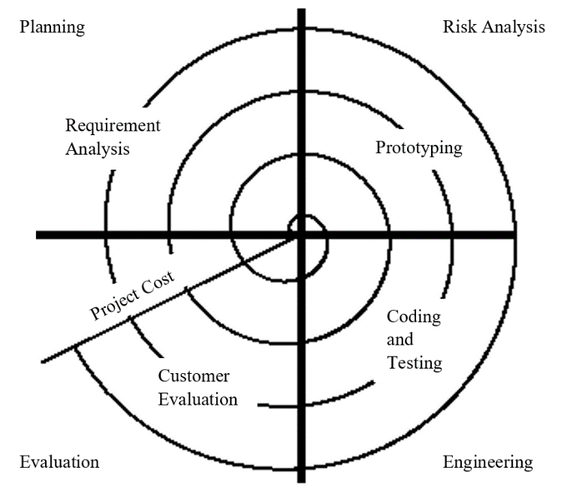

**Fig 6.1:** Spiral Model Diagram

* **Planning Phase:** Here, the requirements like BRS and SRS are gathered.
* **Risk Analysis:** In the risk analysis phase, a process is undertaken to identify risk and alternate solutions. A prototype is produced at the end of risk analysis phase. If any risk is found then alternates are suggested and implemented.
* **Engineering Phase:** In this phase software is developed, along with testing at the end of the phase. Hence in this phase the development and testing are done.
* **Evaluation phase:** This phase allows the customer to evaluate the output of the project to date before the project continues to the next spiral.

1. **Working Model**

Based on the standard model, the method of building the current system is relatively similar approach while the overall process in the current project to be performed forth shall be divided to three phases:

* PHASE I: (Data Processing)
* Here, the availability of required data and sources alongside shall be noted.
* Our target data includes:  
   Product List of: Pharmaceutical Drugs, Cosmetics, Health Care  
   Information on: Pharmaceutical Drug, Medical Conditions
* Data will be gathered and processed (classified and ordered) according to parameters formatted acceptable by the system for data entry in later section.
* PHASE II: (System Design)
* A sketch of Front End Design
* PHASE III: (Deploy, Revamp)

Here, each phase shall consist of five group of activities to be performed:

* Planning:
* Construct
* Execution
* Monitoring
* Feedback

1. **Diagrammatic Representation**

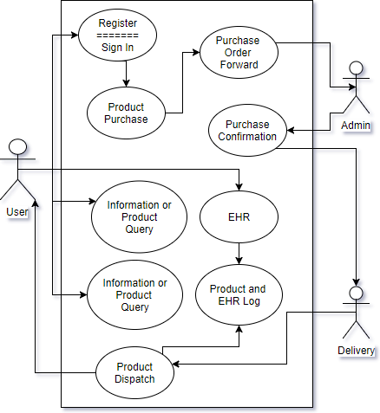

**Fig 6.2:** Use Case Diagram of Online Medication System

1. **Risk Analysis**
2. **EXPECTED OUTPUT**

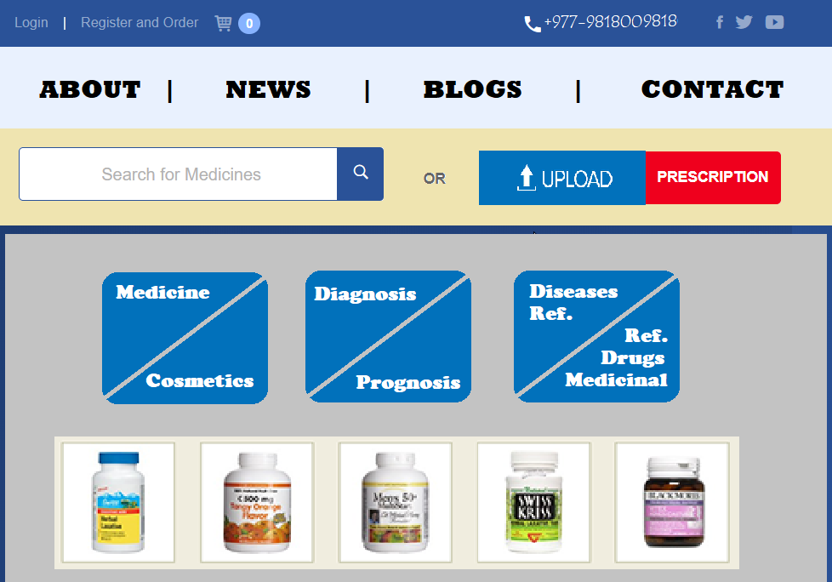

**Fig 7.1:** Expected Output of Front Page

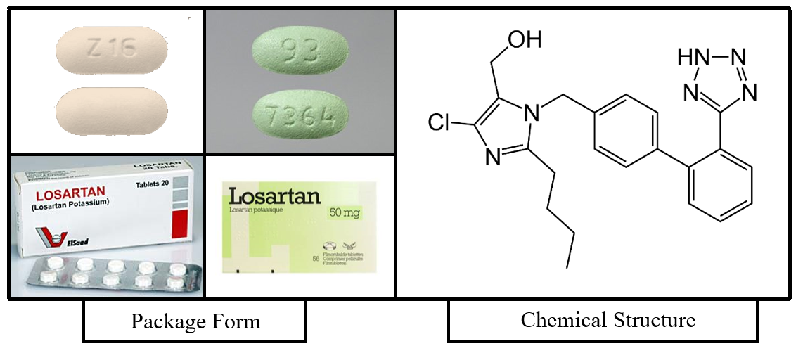

|  |  |
| --- | --- |
| **Brand Name:** | RESERT-H |
| **Generic Name:** | Losartan Potassium 50 mg  + Hydrochlorothiazide 12.5 mg |
| **Form:** | Tablet |
| **Administration:** | Orally |
| **Dose (Adult):** | Average: 50 mg  Safe Limit: 25 to 100 mg once a day Divided Doses: 1 or 2 times a day |
| **Manufacturer:** | Quest Pharmaceuticals Pvt. Ltd. |
| **Class (Schedule):** | Class B (Prescription) |
| **Therapeutic Use:** | Heart Failure (MI), Hypertension, Ventricular Enlargement |
| **Precaution during:** | Pregnancy, Breast-feeding |
| **Overdose:** | Angioedema, LBP, Kidney Failure |
| **Family (Chemistry):** | Sartans, Angiotensin II Receptor Blockers (ARBs) |

**Fig 7.3:** Expected Output of Pharmaceutical Drug Information

1. **SCHEDULE**

|  |  |  |  |  |  |  |  |  |  |  |  |  |  |  |  |  |  |
| --- | --- | --- | --- | --- | --- | --- | --- | --- | --- | --- | --- | --- | --- | --- | --- | --- | --- |
| **Work Phase** | **Month**  **Task** | **July** | | | | **August** | | | | **September** | | | | **October** | | | |
| Data  Process | **Collect Data and Requirements** |  |  |  |  |  |  |  |  |  |  |  |  |  |  |  |  |
| System Design | **FE Design Specification** |  |  |  |  |  |  |  |  |  |  |  |  |  |  |  |  |
| **Back End Design  Implementation** |  |  |  |  |  |  |  |  |  |  |  |  |  |  |  |  |
| **CMS Development** |  |  |  |  |  |  |  |  |  |  |  |  |  |  |  |  |
| Deploy, Revamp | **Data Entry to sys,  Test and Debug** |  |  |  |  |  |  |  |  |  |  |  |  |  |  |  |  |

**Table 9.1:** Gantt Chart of Work Routine

1. **REFERENCE**

* **FOR INTRODUCION:**

<https://economictimes.indiatimes.com/industry/healthcare/biotech/pharmaceuticals/how-e-pharmacy-can-empower-consumers/articleshow/47418472.cms>

<http://draw.io> (For the diagram)

<https://www.quora.com/I-am-planning-to-start-an-online-pharmacy-store-What-are-the-steps-to-be-taken-to-start-the-online-pharmacy-store>

<http://www.medsafe.govt.nz/profs/class/classintro.asp>

[Site visited on: 27th June, 2018]

* **FOR LITERATURE REVIEW:**

al-Ghazal, Sharif Kaf (October 2003). "The valuable contributions of Al-Razi (Rhazes) in the history of pharmacy during the Middle Ages" (PDF). Journal of the International Society for the History of Islamic Medicine. 2 (4): 9–11. ISSN 1303-667X. OCLC 54045642.

History of Pharmacy Web Pages - Sweden´s oldest pharmacies Archived 23 June 2011 at the Way back Machine.

"PY 1314 Vn + frr. (Cii)". DĀMOS: Database of Mycenaean at Oslo. University of Oslo. Raymoure, K.A. "pe-re". Minoan Linear A & Mycenaean Linear B. Deaditerranean. "The Linear B word pa-ma-ko". Palaeolexicon. Word study tool of ancient languages.

<https://www.apu.edu/live_data/files/288/literature_review.pdf>

[Site visited on: 28th June, 2018]

<http://pathinfo.wikia.com/wiki/Electronic_Medical_Record_(EMR)_/_Electronic_Health_Record_(EHR)_-_Resource_Directory>

<https://www.npr.org/sections/health-shots/2016/11/08/501087493/should-i-trust-wikipedia-with-my-health>

<https://www.ncbi.nlm.nih.gov/pmc/articles/PMC4376174/>

<https://www.theatlantic.com/health/archive/2014/03/doctors-1-source-for-healthcare-information-wikipedia/284206/>

[Site visited on: 4th July, 2018]

* **FOR METHODOLOGY:**

<https://pdfs.semanticscholar.org/3d85/8e3df0997f3fdaacab386c4eae9117e90ccb.pdf>

<http://win.ua.ac.be/~sdemey/Tutorial_ResearchMethods/ResearchMethds02_Reviewing.4pgup.pdf>

[Site visited on: 27th June, 2018]

<https://repository.up.ac.za/bitstream/handle/2263/28684/03chapter3.pdf?sequence=4>

<http://www.sociology.kpi.ua/wp-content/uploads/2014/06/Ranjit_Kumar-Research_Methodology_A_Step-by-Step_G.pdf>

<http://istqbexamcertification.com/what-is-spiral-model-advantages-disadvantages-and-when-to-use-it/>

[Site visited on: 29th June, 2018]